

Witan Investment Trust Cyber Security Report

Student ID: R00201303
Name: Laiba Asif
Group: COMP1D-Y
Date: 05/10/2021
Module: Computer Security Principles
COMP6035_26210

Contents
Contents 2
Objectives…………………………………...…………………………………………………….3
Task 1: 3
Introduction 3
Portfolio overview: 3
Witan’s regional breakdown 3
Witan’s sector Breakdown (%) 4
Witan’s top 20 holdings (%) 4
Assets 5
Websites for details on current malware 6
Malware threats 7
Ransomware 16
Task 2: 16
What Is Foot printing: 16
Weaknesses of Witan Investment Trust Plc 17
Opportunities/Solution 18
Task 3: 19
Social Engineering Effect on Witan Investment Trust 20
Physical Authentication 20
Digital Authentication 21
Authentication Recommendation For Physical Access 21
References 22

Objectives:

Task 1: | Task 2: | Task 3:
Company’s introduction and assets. | Foot printing and methods | Social engineering and its effects.
websites for cybersecurity awareness. | Company weaknesses and its solution. | Physical and digital authentication best practices.
Identified malware. | Social networking policy. | Authentication against physical access.

Ransomware overview.

Task 1:

Introduction [1, p. 8]:
Witan is a global investment trust that strives to achieve shareholder wealth and outperform the market by investing in a broad range of listed companies across diverse equity markets. Witan’s company size is 1-10 employees, currently there are 7 employees working in witan investment trust. A variety of approaches are used to select witan’s strategic asset allocation and construct a portfolio to offer the shareholders a broad range of investment opportunities. The portfolio is continuously monitored and adjusted as needed. Over the long term, achieve an investment total return exceeding that of the Company's benchmark, and increase dividends ahead of inflation. Witan invests primarily in listed companies across global equity markets, using a multi-manager strategy. Its actively managed portfolio offers investors a unique way to gain exposure to global economic growth through its exposure to a wide range of markets and sectors. Additionally, the multimanager approach reduces the chances of these risks occurring if a single manager is relied upon. As a board and executive with extensive management experience, witan have selected good managers for their assets as well as delivered sound, independent governance over the long term.

Portfolio overview:

Witan’s regional breakdown [1]:
- North America: 39%
- United Kingdom: 21%
- Europe: 17%, Asia: 7%
- Japan: 3%, Other: 1%
- Investment companies: 12%.

Witan’s sector Breakdown (%) [1]:

Information technology 15 | Consumer discretionary 9
Industrials 13 | Materials 8
Health care 11 | Energy 2
Communication services 10 | Utilities 1
Consumer staples 9 | Investment companies 12
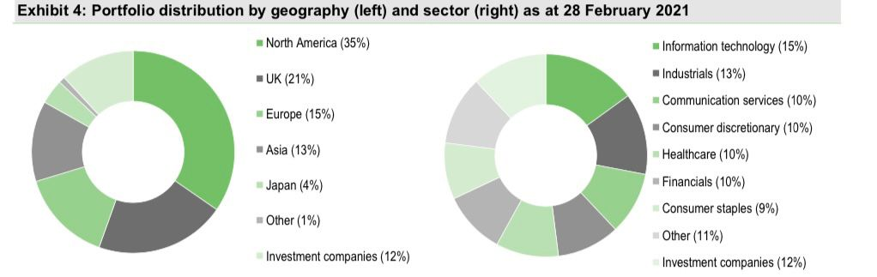

Witan’s top 20 holdings (%) [1, pp. 2-6]:

- GMO Climate Change Fund: 3.7
- Apax Global Alpha: 3.0
- Alphabet: 2.0
- Princess Private Equity: 1.9
- Vanguard S&P 500 ETF: 1.7
- Unilever: 1.6
- Electra Private Equity: 1.5
- Charter Communications: 1.4
- Taiwan Semiconductor: 1.4
- BlackRock World Mining Trust: 1.3
- Syncona: 1.2
- Diageo: 1.2
- PayPal: 1.2
- Intuit: 1.2
- Schroder Real Estate Investment Trust: 1.0
- Thermo Fisher Scientific: 1.0
- Heineken: 1.0
- Natwest: 0.9
- BT: 0.9
- Facebook: 0.9.
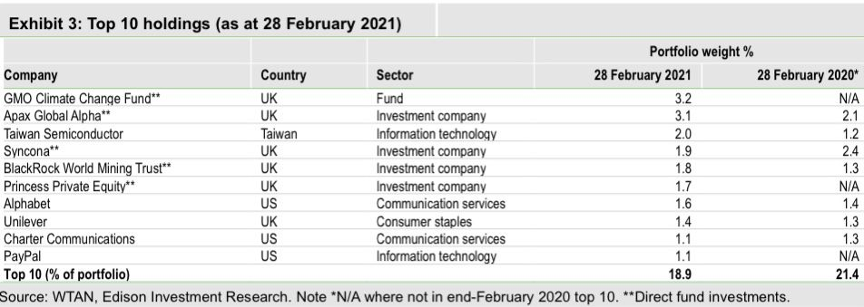

Assets [2, pp. 4-20]:
Customer list: For businesses in a variety of industries, customer relationships are a valuable intangible asset. Customer connections require a large amount of human and financial resources to build, maintain, and upgrade. In some cases, supplier or customer contracts result in intangible assets that can be identified. Customer-related intangible assets, on the other hand, are information acquired via recurrent transactions, whether or not there are underlying contracts. Companies can and do lease, sell, acquire, or otherwise trade such data, which is typically arranged as client lists.
Human capital: "Human Capital Risk Management" aims to define, identify, evaluate, and manage risk that may have an impact on employee performance and limit or prevent them from achieving their portion of the company objective. Most of the time, determining the value of tangible and intangible real and personal business assets is simple. However, valuing personnel for the purpose of calculating the loss of use they represent is substantially more difficult, owing to several issues, including:
- There is no accounting treatment for human resources.
- The concept is extremely personalized and adapted to a single business.
- For analysis, there is a scarcity of consistent data.
Intellectual property: Some types of intellectual property are capital assets and may be reported as intangible assets on a company's balance sheet. Intellectual property is a broad term that can refer to a variety of things. Patents, trademarks, copyrights, trade secrets, and unique ideas are all examples of intellectual property. While some of these assets are reflected on a company's balance sheet, determining their true market worth is frequently challenging.
Stocks: Common stock is seen as an asset by investors. You own the property, which has a market value and can be sold for cash. Stock is something you utilize as a business owner to acquire an infusion of funds. The capital is saved, used to purchase machinery or property, or utilized to cover operating costs.
Witan’s asset class breakdown [1]:
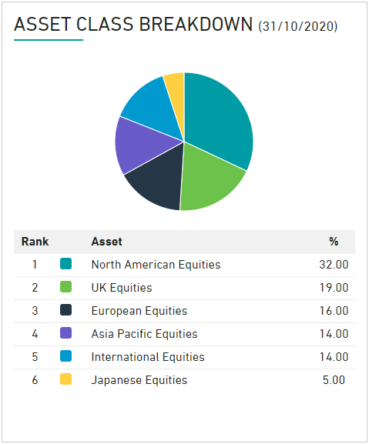

Websites for details on current malware [3, pp. 25-39]:

- www.onpage.com
- www.mcafee.com
- www.cisecurity.org
- www.gatefy.com
- www.jupyter.org
- www.spanning.com
- www.purplesec.us
- www.opentext.com
- www.zvelo.com
- www.crowdstrike.com

Malware threats
1.ZeuS [4, pp. 6-18]:
Zeus malware (also known as ZeuS or Zbot) is a Trojan Horse malware. This malware is designed to perform harmful operations on the victim's computer and runs on various versions of Microsoft Windows. The main goal of this malicious malware was to use man-in-the-browser keystroke logging and form grabbing to steal financial information. CryptoLocker ransomware is also installed via Zeus virus. Phishing techniques and drive-by downloads are the most common methods of infection.ZeuS, often known as crimeware, is a well-known financial Trojan horse malware. This malware uses web browsers and secured storage to steal data from compromised systems. When a computer is infected, the stolen data is sent to a bot command and control (C&C) server, where it is stored. It’s certainly the most common malware used by financial fraudsters. ZeuS has evolved over time to encompass a comprehensive set of data-stealing capabilities:
- Data sent over HTTP forms is stolen.
- Account credentials stored in Windows Protected Storage are stolen.
- X.509 client-side public key infrastructure (PKI) certificates are stolen.
- FTP and POP account credentials are stolen.
- HTTP and Flash cookies are stolen and deleted.
- For the purpose of stealing information, modifies the HTML pages of target websites.
- Victims are redirected from target web pages to pages controlled by the attacker.
- Scrapes HTML from target webpages and takes screenshots.
- Looks for files on the infected machine and uploads them.
- Changes the hosts file on the local machine (percent system root percent \system32\drivers\etc.\hosts)
- Downloads and runs any software it finds.
- Deletes important registry keys, preventing the PC from booting into Windows.
The following is a list of modules that operate with ZeuS at the moment:
- Zeus Kit for Version
- Backconnect
- Firefox form grabber
- Jabber (IM) chat notifier
How does ZeuS work?
It has two primary methods for infecting your computer with the trojan, both of which are quite effective. The first approach employs spam communications: hackers fool a percentage of users into clicking on their link by sending hundreds or even millions of spam emails and social media messages, and then posting on social media. Users are then sent to a page on a malicious site. The Zeus malware can even access genuine people's email and social media accounts, allowing it to send out even more messages that appear to be legitimate. When you download files from the Internet, the Zeus trojan could also infect your computer. Even if you're downloading from a reputable and trustworthy source, there's a risk the files will be infected with the malware because Zbot may infiltrate and implant its code into websites.
What Does It Do to Computers?
The Zeus botnets may identify when you enter sensitive information such as banking details or passwords via key logging and website monitoring, and then exploit that information to steal your money.
Tips for Avoiding ZeuS Viruses [3, pp. 15-28]:
Spam emails and phishing scams are the most prevalent ways for Zeus malware to spread. Keep in mind that many of these messages may appear to be originating from reputable sources. A little caution can help you avoid getting Zeus virus on your computer.
- Make sure your antivirus software is up to date.
- Use anti-spam and anti-phishing software to protect yourself from fraudulent websites and spam.
- scan your computer on a regular basis to look for suspicious files.
- On social media networks, stay away from spam and deceptive messages.
- Do not click on any links that appear to be dodgy.
- Downloading unauthorized or unknown software is not a good idea.
How To Remove IT?
Any sort of Zeus malware can be found and removed with Avast Antivirus. If Avast detects a virus on your computer, it will be sent to the Virus Chest, where you can safely destroy it. It is not required, however it is recommended that you first go offline. Other options for terminating ZeuS are:
- To end the ZEUS Fake Windows Process, type Rkill.
- To get rid of the ZEUS infection, use Malwarebytes.
- Use HitmanPro to remove ZeuS.
- To remove Potentially Unwanted Programs, use Zemana AntiMalware.
HitmanPro:
- HitmanPro is available for download.
- Install HitmanPro on your computer.
- The start screen will appear when HitmanPro begins to run. To run a system scan, click the "Next" button.
- Wait for the HitmanPro scan to finish before hitting the start button. HitmanPro will now begin scanning your computer for harmful apps. It will take a few minutes to complete this process.
- When HitmanPro has finished scanning, it will show a list of all the malware it has discovered. To delete the harmful apps, click the "Next" button. Summary of the HitmanPro scan. To eliminate malware, click Next. - To begin the free 30-day trial and remove any malicious files from your PC, click the "Activate free license" button.
- Activate the HitmanPro license key for free.
- To finish the HitmanPro activation, enter your email address. You can close HitmanPro and proceed with the rest of the instructions after the process is finished.
2.Spyware [5, p. 8]:
It’s a malicious software that infiltrates your computer and steals your browsing history and personal information. Spyware is a sort of malware, which is harmful software that is designed to obtain access to or damage your computer without your permission. One of the most widespread risks on the internet is spyware. It is easy to infect your device, and it is difficult to detect. Spyware is a concern to both organizations and individual users because it can steal important data and cause network damage. Because some varieties of spyware might install additional software and change your device's settings, it's critical to use strong passwords and keep your gadgets up to date.
How does it work [1]?
Spyware collects your personal data and sends it to advertising, data businesses, or other third parties. Spyware is used for a variety of reasons. Its typical goal is to track and sell your internet usage data, steal your credit card, or bank account information, or steal your identity. How? Spyware tracks your login and password information, as well as your personal data, and monitors your online activities.
What can you do to help prevent spyware [3, pp. 3-8]?
- To help prevent spyware, follow these four basic measures.
- Emails from unknown senders should not be opened.
- Downloading files from untrustworthy sites is not a good idea.
- Pop-up adverts should not be clicked.
- Use a reliable antivirus program.
How to remove it [1]?
If you suspect your device has been infected with spyware, do a scan with your current security software to ensure it has removed everything possible. Next, download and run a virus eradication tool, such as Norton Power Eraser, which is available for free. Other renowned anti-spyware eradication solutions are also available. Some of them only work if you start the scan manually. Others keep an eye on your computer all the time to make sure spyware isn't modifying or monitoring your data.
3.Ursnif [1]:
Also known as Gozi, IFSB, or Dreambot, is a high-risk trojan-type malware that collects and stores sensitive data. Because it is spread through spam email campaigns, this malware usually infiltrates systems without the user's permission e.g., "TicketSales Email Virus", "Swisscom Email Virus". Ursnif is a banking trojan that has been discovered spreading via automated exploit kits, spearphishing assaults, and malicious URLs. Gozi is spread by malicious websites' SEO poisoning and is supplied as JScript in a ZIP package, typically disguised as an important document. It is fileless after installation, residing in the registry and injecting the payload into authorized processes. Gozi takes a sample of the infection chain and unpacks it statically.
How does Ursnif work [7, pp. 8-17]?
A Microsoft Word document is extracted from the password-protected zip file after entering the password provided in the email text. The file extensions for these Word documents are doc and docx. A text message written in German is also included in the Word document. The user is directed to enable macros in MS Word via this notification. The malware dropper checks other security measures such as Protected Mode after macros have been enabled. The Ursnif virus is dropped into the system after the dropper confirms a susceptible Windows host. Ursnif then launches (runs.exe) into the system and begins stealing numerous sets of data from it, which he then saves in a file. It subsequently establishes a connection with a malicious command and control (C&C) server and transfers the info file into it.
Elimination [8, p. 7]:
If your computer is connected to the internet, disconnect it and run a full system scan using anti-malware software to eliminate the infection.

4.NanoCore [6, p. 5]:
:
This malware is a high-risk RAT that provides attackers with details on the device name and OS. This information is used to carry out various malicious activities, such as manipulating confidential files, hijacking webcam and microphone, stealing login credentials. The new version, dubbed NanoCore v1. 2.2, may be used to conduct an assault against Windows PCs to steal hashed passwords, perform keylogging, and quietly capture audio and video using webcams, according to researchers at LMNTRIX Labs, who first reported the discovery.
How Does It Work [1]?
The majority of malware is targeted at a single form of attack. However, once hackers obtain complete, anonymous access over compromised devices, NanoCore empowers them to do almost anything they want.
Techniques [7, pp. 8-14]:
- Phishing: An email attachment with a malicious RTF file is delivered to the victim's Outlook.
- Deployment of the Payload: When the user opens the attachment, the trojan is silently installed on the device.
- Compromise on Business Email: To obtain access to financial information and other business-critical data, keyloggers are used to steal Office 365 passwords.
- Ransomware: Information is transferred to hackers' servers. The victims are then required to pay a fee to recover their Office 365 data.
Infection Details [1, p. 5]:
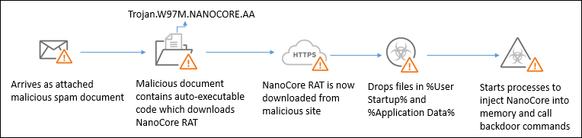
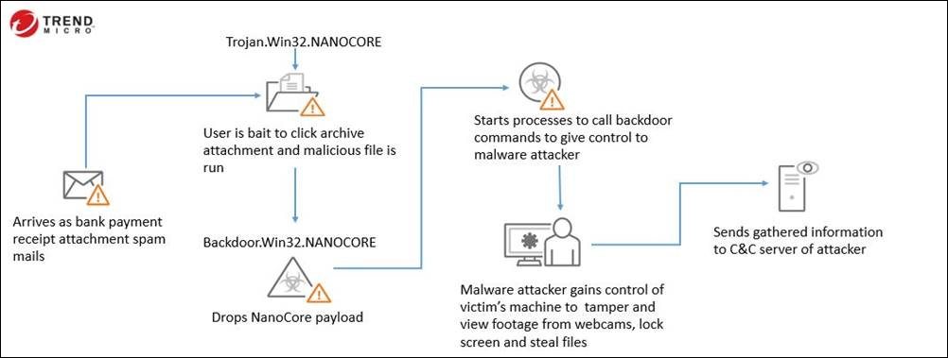
How to revome it [1]?
- Autoruns is an application that you can download. This program displays the locations of auto-start applications, the Registry, and the file system.
- Safe Mode should be selected when you restart your computer.
- Run the Autoruns.exe file after extracting the archive.
- Uncheck the "Hide Empty Locations" and "Hide Windows Entries" settings in the Autoruns application by clicking "Options" at the top. Click the "Refresh" icon when you've completed this step.
- Locate the malware file you want to remove from the list offered by the Autoruns application.
5.Mirai [1]:
A malware that infects ARC-based smart devices, turning them into a network of remotely controlled bots or "zombies." DDoS assaults are frequently launched via a botnet, which is a network of bots. Mirai, like most malware in this category, is designed to accomplish two goals:
- To expand the botnet, find and compromise IoT devices.
- Launch DDoS assaults in response to commands from a remote C&C.
What is the mechanism of the Mirai malware [1, p. 9]?
Mirai searches the Internet for IoT devices that use the ARC processor. The operating system on this chip is a stripped-down version of Linux. Mirai can log onto the device and infect it if the default username and password combination is not altered. IoT, is a catch-all phrase for smart gadgets that can connect to the Internet. Baby monitors, cars, network routers, agricultural gadgets, medical devices, environmental monitoring devices, and home appliances are examples of these devices.
Top countries of Mirai DDoS attacks [1]:
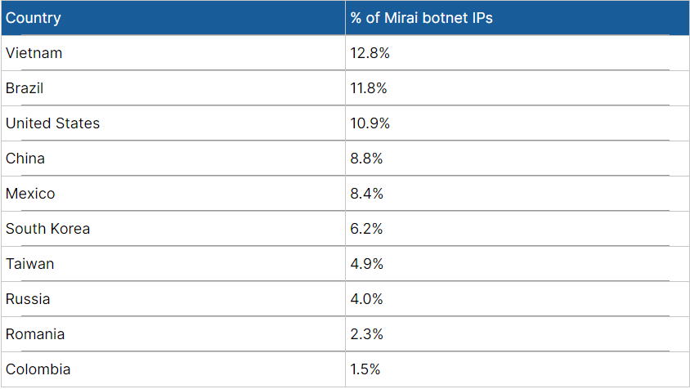

All Mirai-infected devices that have been discovered so far have been geo-located [1]:
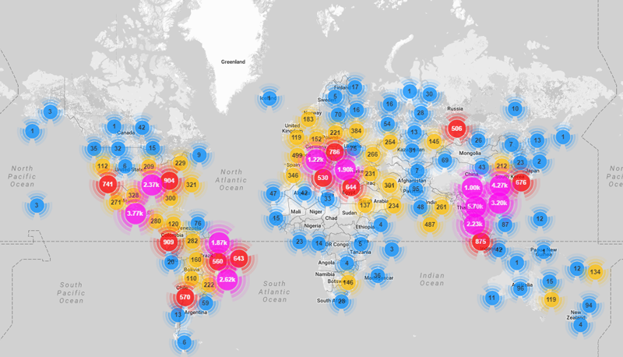
How to remove Marai [1]:
- Select Settings by right clicking the Start button.
- Update & Security can be found by scrolling down.
- Select Recovery from the left-hand menu.
- The Advanced Startup section can now be found by scrolling down.
- Restart now by clicking the button.
- Troubleshoot is the option you should choose.
- Select Advanced.
- Choose Startup Options from the menu.
- Restart your computer by pressing the button.
- Press the number 5 now. Enable Networking Safe Mode.
6.Jupyter [5, pp. 3-8]:
It is a backdoor Trojan that works as an information stealer. It can be used to steal personal information from particular browsers, infect machines with other malware, run PowerShell scripts, commands, and hollow processes, among other things. The techniques of distribution is infected email attachments, fraudulent web adverts, social engineering, and software 'cracks' are all possible sources of infection. It’s a backdoor trojan, password-stealing malware, information straled.
How does it work [9, p. 9]:
The process starts when naïve consumers mistakenly believe the attachment is linked to their job. The executable (.EXE) file in these compressed ZIP attachments starts the rest of the procedure. When it first launches, a.NET C2 client (the Jupyter loader) is placed on the device's RAM, which then downloads a PowerShell script that runs the.NET module.The device's information is then stolen using two functions loaded in memory (which is why it is considered an Infostealer Trojan). One function collects system information, while the other collects passwords, credentials, cookies, and digital certificates from Firefox and Chrome browsers.
Elimination [4, p. 7]:
Manual malware eradication is a difficult operation; it's usually best to let antivirus or anti-malware solutions handle it for you. Combo Cleaner Antivirus for Windows is recommended for removing this infection. If you want to manually remove malware, follow the steps described above for NanoCore malware removal.
7.worm [3, p. 8]:

A computer worm is a sort of virus that duplicates itself and transmits it from one machine to another. A worm may replicate itself without the need for human intervention, and it does not require attachment to a software application to cause harm. For instance, WannaCry and Petya/Not-Petya ransomware. These have a worm component, which allows the malware to replicate and spread through back doors in other network systems.
What is the mechanism of a worm virus [6, p. 6]?
A computer worm is a self-replicating virus program that spreads to other systems by replicating itself. It frequently spreads over a computer network, relying on security flaws on the target computer to gain access. It will scan and infect additional computers using this system as a host.
How to remove them [10, pp. 1-5]?
- Use a virus removal tool like Microsoft's Malicious Software Removal Tool to get rid of viruses.
- To launch Search, press Win+S, type "restore," and then click "Create a restore point" in the results.
- Check "Disable System Protection" after clicking Configure.
- If you have a third-party antivirus product, turn it off.
- Restart the computer to the login screen, then click "Power," then "Restart" while holding Shift.
- "Troubleshoot," then "Advanced Options," will appear.
- Click "Startup settings," then "Restart" if you're running Windows 10 or Windows 8.
- To enter Safe Mode with Networking in Windows 10 or Windows 8, click F5 or 5 at the Boot Options screen.
- Double-click the malware eradication tool on your desktop now that you're in Safe Mode.
- select "Scan Now" from the drop-down menu (or something similar).
- Viruses, worms, and other malware are quarantined.
- Select "Restart" from the Start menu, then "Power."
- System Restore should be enabled again.
- Set your antivirus software to keep an eye on your computer in real time.
- If you don't already have antivirus protection, turn on Windows Defender.
8.Adware [5, p. 15]:
This is a type of malware that lurks on your computer and displays ads to you. Some adware tracks your online activity to serve you personalized adverts. Malwarebytes downloads for free download. Adware makes money for its creator by displaying web adverts in the software's user interface or on a screen that appears in front of the user during the installation process. That's when you start seeing dubious magical weight-loss programs, promises for get-rich-quick secrets, and phony virus warnings that tempt you to click. You may also notice the appearance of additional tabs, a change in your home page, results from a search engine you've never heard of, or even a referral to an NSFW website.
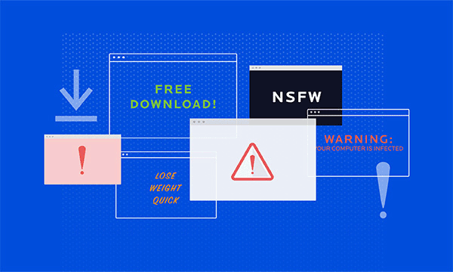
“Adware is unwanted software designed to throw advertisements up on your screen.”
How Adware works [1, p. 7]:
There are two basic ways for adware to gain access to your computer:
- In the first, you download an application (typically freeware or shareware) that silently installs adware without your knowledge or consent. Because the program's creator joined up with the adware provider, this is the case.
- The second strategy is equally devious. You've arrived at a website. Maybe it's a reputable website; maybe it's a dubious one. Adware, which takes use of a vulnerability in the user's web browser to perform a drive-by download, can infect it in either case.
After settling in, the adware begins collecting information about you, leading you to fraudulent websites, and bombarding your browser with more adverts.
How to remove it [3, pp. 4-8]?
If you think adware has infected your Mac or Windows PC, there are a few things you may do to get rid of it. To begin, make regular backups of your files. You can try to uninstall the adware using your operating system's relevant program (for example, Add/Remove on the Windows platform). However, you must be able to recognize the adware application's identity, or the adware must not have a Resuscitator, which are files meant to bring a program back to life after it has been uninstalled. If that's the case, get Malwarebytes, a reputable antivirus application. Run a scan, and it'll bag, tag, and dump any threats it finds. It's a good idea to change your passwords now, not just for your computer, but also for your email, social media accounts, preferred shopping sites, and online billing accounts.

Ransomware [3, pp. 1-23]:
Ransomware is a type of malware that encrypts your files and holds them captive on your computer or device. The files are still on your computer, but the ransomware has encrypted them, rendering your data inaccessible. Hackers encrypt and lock files on your computer or device using malicious software. They can then kidnap those files and prevent you from accessing your data until you pay a ransom. They may or may not provide you a decryption key to regain access if you pay. Ransomware works by getting access to your computer or device and then locking and encrypting the information saved on it. What causes this to happen? It frequently occurs when victims unintentionally download malware via email attachments or links from unknown sources, which are usually hackers. Ransomware encrypts your data and stops you from accessing them. This malicious malware effectively holds your files captive, wreaking devastation on a massive scale for larger businesses. While a ransom is being requested, there is no guarantee that your data will be returned if you pay it. Even if you pay the attackers, the decryption key may never be given to you. As a result, ransomware is a threat. This makes it difficult to navigate ransomware. Ransomware assaults come in a variety of shapes and sizes. Although some varieties are more dangerous than others, they always have one thing in common: they demand a ransom. Here are seven forms of ransomware you should be aware of.
1. Malware based on cryptography
2. Locker rooms
3. Beware of scareware
4.Doxware
5.RaaS
6. Mac ransomware (RaaS)
7. Mobile devices infected with ransomware
Recent Ransomware Attack:
CNA Financial on 21 March 2021
Perpetrator: Phoenix
Ransom Demanded: Unknown and ransom paid is Unconfirmed (reported to be $40m by people close to the incident)
Attack vector: Unknown
Noteworthiness: There are two aspects of this attack that stand out. To begin with, the quantity of the alleged ransom payment; while CNA has not confirmed this, it would be the largest known ransom payment to date. Second, the use of Evil Corp's Phoenix Locker ransomware, which was sanctioned by the US government in 2019, effectively prohibiting any legitimate ransom payment. Phoenix was the threat actor, according to CNA, and it was "not a sanctioned company," according to a writer from security publication Bleeping Computer.
According to David Carmiel, CEO of threat intelligence firm KELA, although the initial attack vector has not been officially confirmed, it is suspected to have employed a malicious browser update given via a genuine website. Although it is unclear how elevated privileges on the system were obtained in order to infect the entire network, Carmiel claims that this "frequently happens through the use of known vulnerabilities and subsequent social engineering." CIOs should develop security protocols to ensure that all important stakeholders and staff do not download updates without first validating their validity, according to him.

Task 2:

What Is Foot printing:

The practice of gathering as much knowledge as possible about the target system in order to find ways to break into it. An ethical hacker must spend time profiling a company, obtaining information about the host, network, and people associated with the company. Ip addresses, Whois data, DNS information, the OS system utilized, employee email ids, and phone numbers, among other things, are collected.
How Footprinting helps [7, pp. 3-8]?
- Know the Company's Security Position - The information acquired will assist us in gaining an overview of the company's security posture, such as specifics on the presence of a firewall, application security setups, and so on.
- Reduce Attack Area - Can detect a limited number of systems and focus on a single target. We'll be able to focus on fewer systems because of this.
- Identify vulnerabilities - We can create a database including the vulnerabilities, threats, and loopholes that exist in the target organization's system.
- Draw Network Map - aids with the creation of a network map of the target organization's networks, including topology, trusted routers, server presence, and other data.
Techniques [5, p. 6]:
Active Footprinting: Active Footprinting is the practice of gathering information on a target utilizing tools and techniques such as ping sweeps and the traceroute command. Because Active Footprinting might trigger a target's Intrusion Detection System (IDS) and be logged, it necessitates a high level of stealth.
Passive Footprinting: The technique of acquiring information on a target using harmless, or passive, ways is known as passive fingerprinting. Passive Footprinting includes browsing the target's website, checking employee social media profiles, searching for the target's website on WHOIS, and conducting a Google search for the target.
Example: Passive footprinting involves looking at a company's website, whereas active information collecting involves seeking to acquire access to sensitive information through social engineering.

Weaknesses of Witan Investment Trust Plc [10, pp. 6-10]:
- Witan Investment Trust Plc has a considerable amount of property that is rented rather than purchased. It needs to pay a lot of rent on these, which adds to its expenses.
- Integration: Due to Witan Investment Trust Plc's current structure and culture, numerous mergers intended at vertical integration have failed.
- Research and Development: While Witan Investment Trust Plc spends more on research and development than the industry average, it spends far less than a select players who have gained a considerable competitive advantage because of their unique goods [2].
- The company's current assets are low in comparison to its current liabilities, which could cause liquidity issues in its operations.
- Because there are fewer workers than the actual job necessary, the workload per worker is considerable. Workers are likely to be less productive because of this psychological stress.
- Employee morale is low as a result of the company's growing culture and politics in recent years [1, p. 7].
- In recent years, competition has increased, and qualified individuals have left the organization, perhaps resulting in a talent scarcity in the coming years.

Opportunities/Solution [1]:
- Internet: The number of people using the internet is increasing all around the world. This means that Witan Investment Trust Plc has the chance to develop its online presence by interacting with its clients via the internet.
- Social Media: The number of people using social media has risen around the world. The three social media networks that have had the most growth in monthly active users are Facebook, Twitter, and Instagram. Witan Investment Trust Plc can utilize social media to advertise its products, engage with customers, and gather feedback [2].
- Technological advancements: technology has several advantages in a variety of fields. To save money, operations can be automated. Technology makes it easier to obtain better data about customers and improves marketing efforts.
- Globalisation: Witan Investment Trust Plc is not limited to its own country as a result of increased globalisation. It can expand its activities to other nations, joining these markets and taking advantage of the chances available.
- Consumers in the business are becoming more health-conscious, and this is a rising market. Witan Investment Trust Plc can benefit from producing products that are good for customers' health [2].
- The import of goods has seen a reduction in trade barriers. This will cut down on the expenses of production inputs.
- Boosted education and training by a variety of institutions has increased the number of skilled labor accessible in the country. This means that if Witan Investment Trust Plc can acquire skilled labor, it will have to spend less money on training and development, resulting in cost savings [2].
why a company's security strategy should include social media [6, pp. 2-8]?
A social media policy essentially spells out how an organization and its personnel should behave online. It aids in the protection of your firm's online reputation and encourages employees to participate in sharing information about the company through their social media networks. A social media policy clarifies the penalties of breaking the rules and is a vital part of your operational HR risk management. If an employee violates the policy, the firm will be entitled to impose any penalties specified in your policies.
A company without a clear social media policy, on the other hand
1) risks damaging its reputation.
2) is at risk of unforeseen repercussions because of a misread post.
3) faces being kicked off a social networking platform for violating site policies.
4) faces having its website hacked.
5) Data breaches: Employees need to understand what information they should post on social media and what they shouldn’t. For example, without a social media policy, employees might upload or post sensitive personal information about your customers.
6) Bullying has always existed, whether on the schoolyard or at work. Some individuals consider social media to be a wild west where anything can happen. Your policy should state that any form of abuse will be treated with zero tolerance. It should also outline the procedure for dealing with and reporting abuse incidents.
7) Cyber-threat: Cyber thieves utilize social media to defraud their victims or to spread malware and viruses.
8) Loss of competitive advantage: Social media is here to stay, and it affects all businesses in some way. Your firm won't be able to get the most out of social media if you don't have a policy in place. You might not be able to stay up with your competitors if your clients aren't engaged. Furthermore, being open to new ways of working and social media might help you recruit new talent.

Task 3:
Social Engineering [5, p. 3]: The term "social engineering" refers to a wide range of malevolent behaviors carried out through human relationships. It employs psychological tricks to persuade users to make security mistakes or divulge critical information. Social engineering attacks are carried out via a series of steps. To carry out the assault, a perpetrator first examines the intended victim to obtain relevant background information, such as potential avenues of entry and weak security mechanisms. The attacker next attempts to acquire the victim's trust and give stimuli for later acts that violate security protocols, such as disclosing sensitive information or granting access to crucial resources. Social engineering is particularly harmful because it relies on human error rather than software or operating system flaws. Legitimate user errors are less predictable, making them more difficult to detect and prevent than malware-based intrusions.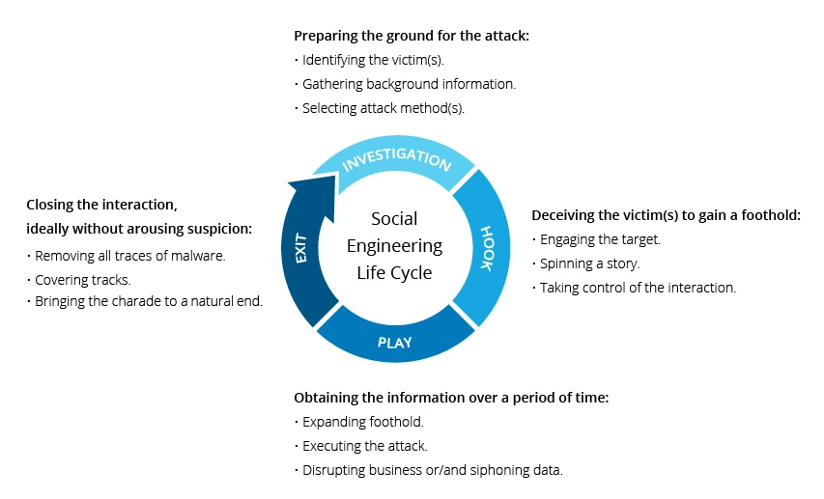

Social Engineering Effect on Witan Investment Trust: Social engineering is used by criminals because it is easier to exploit our inherent need to trust than it is to figure out how to steal your program. Phishing emails, fake-text phoning, and emergency questions are all common tactics used by these shady characters. All of them are meant to appear regular and prompt you to act, such as clicking a link, answering a question eg: Six months ago, your company introduced a new product. Your sales staff wants to discover which client demographics have shown the most interest in the product. They aim to be as effective as possible in targeting the next wave of distribution. Can you answer that question swiftly and confidently as the head of fund administration or a data analyst? or granting access to company and client data. The weakest link in the security chain is the human who accepts a person or scenario at face value. It doesn’t matter how many locks and deadbolts are on your doors and windows if you trust the person at the gate who says they’re a delivery person, and you let them in without first checking to see if they are legitimate. New employees are the most susceptible to social engineering, followed by contractors, executive assistants, and human resources.

Physical Authentication [1]: The first step in constructing a secure and resilient information protection system is to implement a strong authentication solution that verifies the identity of individuals and computing devices who access non-public sections of an organization's network. 1. Select an authentication solution that is appropriate for your business, users, and risk. A flexible strategy that allows an organization to use different authentication techniques based on risk levels may result in a robust system that can be installed quickly and cheaply.
Multi-factor authentication technologies include:
- One-Time Passwords (OTP) are passwords that are only used once.
- CBA (Certificate-based Authentication).
- Authentication based on context.
2. Consider all possible access points Regardless of whether sensitive data is stored on premises or in the cloud, organizations must ensure that access to it is authenticated. Cloud resources should be protected in the same way that remote access to the corporate network is protected.
3. Ascertain that the solution is cost-effective. Overhead in IT administration and management. End users and administrators alike require convenience and transparency in authentication setups. The following are some guidelines that can assist companies in achieving these objectives:
- Controls in the Administration.
- End-User Convenience.
4.Prefer Solutions That Follow Security and Certification Standards. Products that use crypto-algorithms and authentication mechanisms that are based on industry standards are favored. Standards-based algorithms, unlike proprietary algorithms, have been subjected to public evaluation by industry and security experts, reducing the risk of any inherent flaws or vulnerabilities. Furthermore, they have widespread industrial support.

Digital Authentication [2]: The process of validating that individuals or devices is who or what they claim to be in order to grant access to sensitive applications, data, and services is known as digital authentication. Electronic authenticity can be verified in a variety of ways. Here's a rundown of today's most common workplace digital authentication methods.
1.Recognize your device. Endpoint security management platforms can be used to identify authorized devices and grant it rapid access to network resources. It's an extra safeguard to make sure that only the devices that are deemed appropriate are allowed to connect to the network.
2.Authentication using two factors (2FA). A second layer of verification is added to the process of a conventional username and unique secret password. A text message delivered to a specific mobile phone number when access is permitted, the use of hardware and software tokens, biometric authentication, or push notifications to the user are examples of the second layer in 2FA.
3.Key that has been shared in advance (PSK). A PSK is a password that can only be shared by people or devices who have been granted access to the same resources. The most prevalent application of PSK in the workplace is for Wi-Fi authentication. Employees frequently utilize a PSK to obtain access to the business network.
4.Passwords that are unique. When most of us think of authentication, we probably think of utilizing a unique login and password combination. Passwords are still the most used means of digital authentication in the workplace.

Authentication Recommendation For Physical Access [1]:
- Secure the server room: Even before you shut down the servers, and even before you turn them on for the first time, you should double-check that the server room door is securely locked. There should also be policies in place that require those doors to be locked whenever the room is unattended, as well as who has the key or keycode to get in.
- Do not overlook the workstations: Hackers can access or erase information that is critical to your organization from any unsecured machine linked to the network. Unoccupied desks and empty offices (such as those used by personnel on vacation or who have left the company and have not yet been replaced) are particularly vulnerable, as are areas easily accessible to outsiders, such as the front receptionist's desk.
- Ascertain that the most vulnerable gadgets are kept in that secure location.: It's important to remember that it's not just the servers that you need to be concerned about. A hacker can use sniffer software to capture data going across a network by plugging a laptop into a hub. Make sure that as many of your network devices as feasible are in that closed room, or if they must be elsewhere in the building, in a locked closet.
- Prevent outsiders from gaining access to the case.: Thieves who can open the casing and grab the hard disk should be secured from both servers and workstations. It's a lot simpler to get away with a hard disk in your pocket than it is to get away with a whole tower. Many computers include case locks that prevent them from being opened without a key.
Summary [10, p. 7]: Remember that network security begins with physical security. All the firewalls in the world won't keep an attacker from physically accessing your network and PCs, so lock down as well as lock up.

References

[1] | [Online]. Available: www.closecommercialfinance.ie.
[2] | [Online]. Available: 1. www.onpage.com.
[3] | "https://smallbusiness.chron.com/common-stock-considered-asset-62773.html," [Online].
[4] | [Online]. Available: https://learn.financestrategists.com/finance-terms/current-assets/are-bonds-current-assets/.
[5] | [Online]. Available: trendmicro.com.
[6] | [Online]. Available: WWW.EDISONGROUP.COM.
[7] | [Online]. Available: www.edison group.com.
[8] | "https://www.witan.com/," [Online].
[9] | [Online]. Available: https://learn.financestrategists.com/finance-terms/current-assets/are-bonds-current-assets/.
[10] | [Online]. Available: sensorstechforum.com.  (https://markets.ft.com/data/investment-trust/tearsheet/profile?s=WTAN:LSE, n.d.)

Step 1
Right-click an empty space on the desktop and choose Change Desktop Background.

Step 2
This opens the Appearance Preferences to the Background tab. You can choose from any of the pre-installed wallpapers simply by clicking on them.

You should also note that some of these are slideshows, rather than static desktop backgrounds. These cycle through multiple pictures at random intervals. You can tell it’s a slideshow when it has a Play button beneath it and it appears as a stack of photos.

Step 3
Optional. Choose a Style for your desktop background. This tells Ubuntu how to handle wallpapers that don’t fit your screen size perfectly. Your options are:
- Tile – Repeat the image to fill the screen entirely.
- Zoom – Fills the entire screen with the image by zooming in. May crop one of the edges, but won’t mess with the proportions.
- Center – Centers the image without resizing it. May leave blank space.
- Scale – Enlarges the image until it meets at least one of the edges. Maintains proportions, but might leave blank space.
- Stretch – Enlarges the image to fill all blank space. May skew the image, giving it a squished or distorted look.
- Span – Allows your desktop background to extend onto multiple monitors.

I recommend using Zoom, which is the default setting.

You can find other free Ubuntu desktop images online by Clicking Get more backgrounds online. This will open up art.gnome.org/backgrounds in your web browser.

When downloading desktops from the web, you’ll want to choose the resolution that is the closest match to your computer.

If you’re not sure what your resolution is, press the Super (Windows) key and type Monitors.

Launch the Monitor Preferences application and look in the drop-down menu that reads Resolution.

